AI ASSISTENT CODING
NAME: SHAIK NASEEM
ENROLLEMENT NUMBER:2503A52663
BATCH :23
Q1— (AI-Based Code Completion for Loops)
task: Use an AI code completion tool to generate a loop-based
program.
Prompt:
“Generate Python code to print all even numbers between 1 and N
using a loop.”
Expected Output:
• AI-generated loop logic.
• Identification of loop type used (for or while).
• Validation with sample inputs.
PROMPT:Generate Python code to count how many numbers in a list are even and how many are odd. Use a loop and if-else conditional statements. Take the list as user input, display the even count and odd count, and provide a sample input and output.
SOL:n = int(input("Enter N: "))

# Using a for loop to print even numbers from 1 to N
for number in range(2, n + 1, 2):
print(number)
OUTPUT:
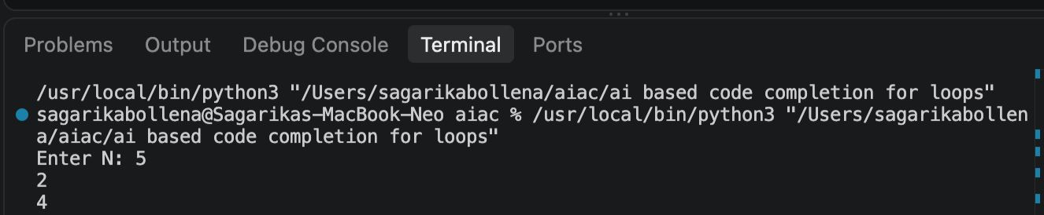

Q2—Task Description #2 (AI-Based Code Completion for Loop with
Conditionals)
Task: Use an AI code completion tool to combine loops and
conditionals.Prompt:
and odd.”
“Generate Python code to count how many numbers in a list are even
Expected Output:
• AI-generated code using loop and if condition.
• Correct count validation.
• Explanation of logic flow
PROMPT:Generate a Python class named User that validates age and email using conditional statements. The age should be valid only if it is between 18 and 100, and the email should contain '@' and '.'. Take age and email as user input, validate both, and display appropriate messages for valid and invalid inputs. Include sample test cases.
SOL:numbers = [10, 7, 4, 9, 12, 3]

even_count = 0
odd_count = 0

for number in numbers:
if number % 2 == 0:
even_count += 1
else:
odd_count += 1

print("Even numbers:", even_count)
print("Odd numbers:", odd_count)
OUTPUT:

Q3 —Task Description #3 (AI-Based Code Completion for Class
Attributes Validation)
Task: Use an AI tool to complete a Python class that validates user
input.
Prompt:
“Generate a Python class User that validates age and email using
conditional statements.”
Expected Output:
• AI-generated class with validation logic.
• Verification of condition handling.
• Test cases for valid and invalid inputs.
PROMPT:
Generate a Python class named Student with attributes name, roll number, and marks. Create methods to calculate the total marks and average marks. Take student details and marks as input, create a Student object, and display the student's name, roll number, total marks, and average marks. Keep the code simple and beginner-friendly and provide sample input and output.
SOL:
class User:
def __init__(self, age, email):
self.age = age
self.email = email

def is_valid(self):
if self.age < 0 or self.age > 120:
return False

if "@" not in self.email or "." not in self.email:
return False

return True

# Valid input
valid_user = User(25, "user@example.com")
print("Valid user:", valid_user.is_valid())

# Invalid age
invalid_age_user = User(-5, "user@example.com")
print("Invalid age:", invalid_age_user.is_valid())

# Invalid email
invalid_email_user = User(25, "user example.com")
print("Invalid email:", invalid_email_user.is_valid())
OUTPUT: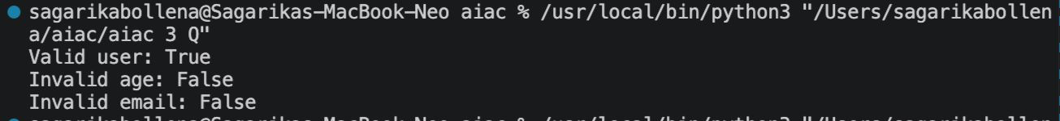
Q4 —Task Description #4 (AI-Based Code Completion for Classes)
Task: Use an AI code completion tool to generate a Python class for
managing student details.
Prompt:
“Generate a Python class Student with attributes (name, roll number,
marks) and methods to calculate total and average marks.”
Expected Output:
• AI-generated class code.
• Verification of correctness and completeness of class
structure.
• Minor manual improvements (if needed) with justification.
PROMPT:Generate a Python class named Student with attributes name, roll number, and marks. Create methods to calculate the total marks and average marks. Take student details and marks as input, create a Student object, and display the student's name, roll number, total marks, and average marks. Keep the code simple and beginner-friendly and provide sample input and output.
SOL:class Student:
def __init__(self, name, roll_number, marks):
self.name = name
self.roll_number = roll_number
self.marks = marks

def total_marks(self):
return sum(self.marks)

def average_marks(self):
return self.total_marks() / len(self.marks)

# Sample input
student = Student("Anita", 101, [85, 90, 78])

print("Name:", student.name)
print("Roll number:", student.roll_number)
print("Total marks:", student.total_marks())
print("Average marks:", student.average_marks())
OUTPUT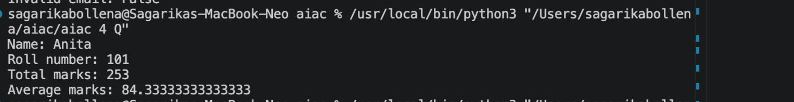
Q5 — Task Description 5 (AI-Assisted Code Completion Review)
Task: Use an AI tool to generate a complete Python program using
classes, loops, and conditionals together.
Prompt:
“Generate a Python program for a simple bank account system using
class, loops, and conditional statements.”
Expected Output:
• Complete AI-generated program.
• Identification of strengths and limitations of AI suggestions.
• Reflection on how AI assisted coding productivity.
PROMPT:Generate a Python class named Student with attributes name, roll number, and marks. Create methods to calculate the total marks and average marks. Take student details and marks as input, create a Student object, and display the student's name, roll number, total marks, and average marks. Keep the code simple and beginner-friendly and provide sample input and output.

SOL:class BankAccount:
def __init__(self, balance=0):
self.balance = balance

def deposit(self, amount):
if amount > 0:
self.balance += amount
print("Deposit successful.")
else:
print("Enter a positive amount.")

def withdraw(self, amount):
if amount <= 0:
print("Enter a positive amount.")
elif amount > self.balance:
print("Insufficient balance.")
else:
self.balance -= amount
print("Withdrawal successful.")

def check_balance(self):
print(f"Current balance: ${self.balance:.2f}")

account = BankAccount()

while True:
print("\n1. Deposit")
print("2. Withdraw")
print("3. Check balance")
print("4. Exit")

choice = input("Enter your choice: ")

if choice == "1":
amount = float(input("Enter deposit amount: $"))
account.deposit(amount)
elif choice == "2":
amount = float(input("Enter withdrawal amount: $"))
account.withdraw(amount)
elif choice == "3":
account.check_balance()
elif choice == "4":
print("Thank you for using the bank account system.")
break
else:
print("Invalid choice. Please try again.")
OUTPUT:
